CONTACT:
Susan Turner / Rodale Books
212-573-0272 / Susan.Turner@rodale.com
60 SECONDS TO SLIM
Balance Your Body Chemistry to Burn Fat Fast!

By Michelle Schoffro Cook, PhD, ROHP

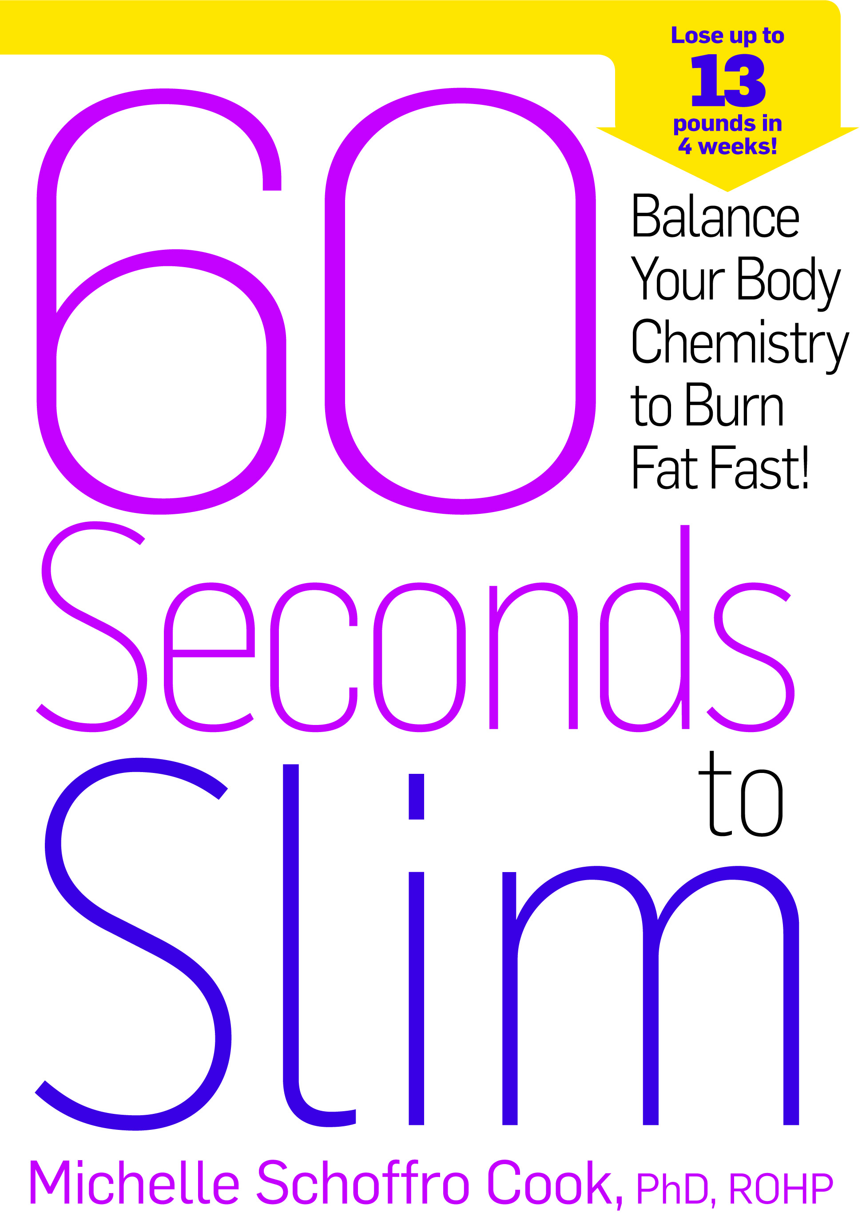
There’s a new fad diet on the market every week – Cut the carbs! Cut the sugar! Cut the food and drink juice! What do all of these diets have in common? They’re short term solutions (with short term results). None of them teach sustainable, healthy and holistic lifestyles.

In 60 SECONDS TO SLIM: Balance Your Body Chemistry to Burn Fat Fast! (Rodale Books; 12/3/13; $26.99), Dr. Michelle Schoffro Cook, PhD, ROHP, brings her two decades worth of research and clinical experience to show readers how you can get healthy from the inside out in just 60 seconds a day. The secret? Balancing your pH (and you don’t have to be a chemist). 60 SECONDS TO SLIM starts you on the road to sustainable weight loss by eliminating the acid-laden foods in your diet and neutralizing their toxic side effects. This breakthrough plan makes it easy to replace high-acid foods with alkaline (pH-balancing) foods. This simple step almost instantly balances your pH levels — and helps your body burn off the excess fat that can accumulate as a result of eating a high-acid diet.

60 SECONDS TO SLIM gets you on track with the “60 Seconds to Slim Plan”, a three-part, natural approach to a healthy lifestyle. Part I helps readers discover the importance of your body chemistry (no prior knowledge needed!). Part II reveals simple 60-Second Weight-Loss Tips to help you maximize your weight-loss efforts. Part III contains delicious recipes designed specifically to help you achieve success on the 60 Seconds to Slim program, including tasty dishes like Maple-Fennel Sausage, Roasted Red Pepper and Caramelized Onion Dip, Grilled Chicken with Citrus Salsa and Strawberry-Rhubarb Crisp.

The plan contains four weeklong phases designed to give readers options – choose five to six 60-second diet and lifestyle changes to crank up the metabolism and melt fat like never before:

- SUBSTITUTE: Make quick kitchen swaps to save your health and your waistline.
- BOOST: Pick five or more fat-busting foods to eat more often!
- STRATEGIZE: Try five or more time-saving strategies to boost your metabolism.
- SUPPLEMENT: Choose up to two healthy, safe and natural supplements proven to slim you down.

Dr. Schoffro Cook and 60 SECONDS TO SLIM will be there along the way to guide you through making healthier choices and helping you maintain this lifestyle in the long run to lose weight and keep it off. All easy and quick choices that will take 60 seconds or less.

ABOUT THE AUTHOR:
Dr. Michelle Schoffro Cook, PhD, ROHP holds advance degrees in natural health and holistic nutrition and has two decades of experience in the field. She has written several books on health and wellness and has been featured in Woman’s World, First for Women, Natural Solutions, Oxygen, The Huffington Post, and more.

